|  |  |
| --- | --- |
| *This question paper consists of 3*  *printed pages, each of which*  *identified by ELEC5471M* | *Drawing instruments and electronic*  *Calculators may be used.*  *Approved dictionaries may be used.* |

**© University of Leeds**

**Examination for the Degree of BEng or MEng**

**(January 2016)**

**School of Electronic and Electrical Engineering**

**ELEC5471M: Data Communications and Network Security**

**Time allowed: 3 hours**

*Attempt any* **three** *questions*

|  |
| --- |
| **Do not write or draw with red ink or red pencil** |

* *To obtain full marks candidates must show how answers are derived*
* *All symbols not specifically defined have their normally accepted meanings*

**Question 1**

1. TCP is considered to provide “reliable data transfer”. What does this mean?

TCP is considered to provide "reliable data transfer," which means it ensures the in-order delivery of all data. This is achieved through various mechanisms that enhance the service provided by TCP, especially when operating over networks with varying error rates, such as wired and wireless services​​.

窗体顶端

窗体底端

*[4 marks]*

1. Describe how TCP provides reliable data transfer when using an unreliable service provided by the layer beneath the transport layer?

*[4 marks]*

TCP provides reliable data transfer over an unreliable connectionless service by employing several mechanisms to enhance performance. These include error checking, acknowledgment, sequence numbers, timers, and flow control. These methods collectively ensure that even if the underlying network service is unreliable and does not guarantee delivery or order of packets, TCP can still deliver data error-free and in the correct order. Additionally, TCP incorporates congestion control and connection setup to further improve reliability and efficiency in data transfer​​.

1. Since the development of TCP, wireless communications have become far more common. Consequently the Internet is migrating from a predominantly wired network to one including many wireless links, especially at the periphery. How does this impact the performance of TCP?

*[6 marks]*

The increasing prevalence of wireless communications impacts TCP performance, as TCP was initially developed for wired networks. The difference in error rates between wired and wireless networks affects how TCP manages data transmission and error correction, potentially impacting its efficiency and reliability.

1. The mechanism of ‘Fast Retransmit’ is to avoid some of the problems caused by the TCP flow control mechanism. Explain the problem which Fast Retransmit is designed to alleviate, and its operation.

*[6 marks]*

The Fast Retransmit mechanism in TCP addresses issues in TCP flow control, particularly packet loss. It triggers retransmission of lost packets upon receiving several duplicate acknowledgments, thus improving efficiency without waiting for timeouts​​​​.

**Question 2**

1. An update to the Internet Protocol (IP) from v4 to v6 is gradually being implemented in the Internet. What is the main motivation for this transition (use quantitative arguments) and describe the range of service changes being made?

*[4 marks]*

The transition from IPv4 to IPv6 is primarily motivated by the need for more IP addresses, as IPv4's 32-bit space is insufficient for the growing number of internet devices. IPv6, with its 128-bit space, significantly expands address availability. The change also brings improved efficiency, security, and support for mobile computing.

1. What addressing scheme is proposed for use in WSNs and why?  *[2 marks]*

In Wireless Sensor Networks (WSNs), a two-layer addressing scheme is used, combining a network-wide address and an Internet world-wide address, to efficiently manage both local and global connectivity.

1. What is network address translation (NAT), and what problems does it aim to overcome?

*[4 marks]*

Network Address Translation (NAT) conserves IP addresses and enhances security by allowing multiple devices on a private network to share a single public IP address​​.

1. What is the difference between flow control and congestion control? Describe the objective of each.

*[4 marks]*

Flow control and congestion control are both mechanisms in TCP, but they serve different purposes:

Flow Control: This mechanism aims to match the rate at which the sender is transmitting data with the receiver's ability to process it. It prevents the sender from overwhelming the receiver with too much data too quickly.

Congestion Control: On the other hand, congestion control is concerned with managing the network congestion. It ensures that the network does not become overloaded with too much data, which can lead to packet loss and delays. This mechanism controls the rate of data flow into the network based on current network conditions​​.

1. The majority of Internet traffic uses TCP. Explain why this is the case. Describe what traffic flows use UDP and why. Discuss the impact for varying load conditions on Internet performance if TCP or UDP would be dominant, i.e. carrying the majority of traffic.

*[6 marks]*

The majority of Internet traffic uses TCP because it provides reliable, in-order delivery of packets, which is crucial for many applications like web browsing, email, and file transfers. UDP, on the other hand, is used for time-sensitive traffic where some data errors are acceptable, such as in streaming media or online gaming. This is because UDP has less overhead and can provide lower latency.

The impact of using TCP or UDP under varying network loads is significant. In lightly loaded networks, using UDP might result in some undetected packet loss, but generally, the performance would be acceptable with low delays and reasonable throughput. However, in heavily loaded networks, predominant use of UDP could lead to severe packet loss and unordered packets, causing problems at the application level and resulting in highly variable delays and poor throughput. This is due to UDP's lack of congestion control mechanisms. On the other hand, TCP's congestion control can prevent buffer overflow and excessive packet loss, but it might introduce higher delays due to retransmissions and acknowledgments​​.

**Question 3**

The ISO developed the Open Systems Interconnection layered architectural model to describe communications systems.

1. What is the purpose of having such a layered model?

*[4 marks]*

The ISO Open Systems Interconnection (OSI) layered model is designed with a layered structure for several key reasons:

1. Simplification: By dividing the complex task of network communication into manageable layers, each with a specific function, the model simplifies the design and implementation of network protocols.

2. Modularity: The layered approach allows for modularity, meaning changes or improvements can be made in one layer without affecting others.

3. Interoperability: Different layers can develop independently, promoting interoperability and standardization across networks and devices.

4. Flexibility and Scalability: It provides flexibility in adapting to different technologies and scalability for evolving network requirements.

1. Describe in order, the layers of the ISO open systems interconnection model, and provide an example of a function performed at each layer.

*[8 marks]*

The ISO Open Systems Interconnection (OSI) model is structured into seven layers, each with specific functions:

Physical Layer: Deals with the physical connection between devices and the transmission of raw bit streams over a physical medium.

Data Link Layer: Manages the node-to-node delivery of data, including error detection and handling.

Network Layer: Responsible for the delivery of packets across network boundaries, ensuring correct routing and addressing.

Transport Layer: Ensures reliable data transfer, maintaining end-to-end communication between devices.

Session Layer: Manages sessions between applications, establishing, managing, and terminating connections.

Presentation Layer: Transforms data to provide a standard interface for the application layer, handling encryption, compression, etc.

Application Layer: The closest layer to the end user, providing network services to applications like email and file transfer​​​​.

1. Describe potential disadvantages of using a layered architecture.

*[3 marks]*

Using a layered architecture, like the ISO Open Systems Interconnection (OSI) model, has certain disadvantages:

Complexity: Layered models can add complexity, as each layer is a distinct entity with its own functions and protocols.

Performance Overhead: Each layer may introduce its own overhead, potentially affecting the overall performance and efficiency of the system.

Rigidity: The model may sometimes be too rigid, limiting the flexibility to adapt or optimize across different layers.

Development and Maintenance Challenges: Developing and maintaining such a layered system can be challenging, especially when ensuring compatibility and efficiency across all layers​​.

1. Describe the TCP/IP architecture including in your description the layers and example functions at each layer.

The TCP/IP architectural model, in contrast to the OSI model, comprises the following layers, each with specific functions:

Network Interface Layer: Handles the physical hardware and is responsible for transmitting data over a network.

Internet Layer: Manages logical addressing and routing, enabling data to traverse multiple networks.

Transport Layer: Ensures reliable communication between hosts, including error checking and flow control.

Application Layer: Interfaces directly with the end-user and manages application-specific services such as email and file transfer.

The TCP/IP model is less granular than the OSI model, combining some OSI layers into single layers to simplify the architecture and improve efficiency​​.  *[5 marks]*

**Question 4**

The study of medium access control (MAC) has taken place over many years as technology has developed.

1. In the context of medium access control (MAC) describe methods of fixed resource allocation.

*[2 marks]*

In the context of medium access control (MAC), fixed resource allocation methods include:

Slotted ALOHA: This is a technique where time is divided into slots, and nodes transmit frames in these predefined slots. It's suitable for computer networks due to its simplicity and effectiveness in environments with low traffic.

Frequency Division Multiple Access (FDMA): This method allocates a unique frequency band to each communication channel or device.

Time Division Multiple Access (TDMA): In TDMA, time is divided into slots, and each slot is assigned to a different user or device.

Code Division Multiple Access (CDMA): CDMA allows multiple devices to transmit simultaneously over the same frequency band, using unique spreading codes to distinguish between transmissions.

These methods are designed to efficiently allocate network resources and manage access to the communication medium, each with its own set of advantages and implementation details​​.

1. The original Ethernet definition used a Slotted ALOHA based MAC technique. Describe slotted ALOHA in terms of its suitability for computer networks, list the pros and cons of slotted protocols, and explain the resolution of collisions. *[8 marks]*

The original Ethernet used a Slotted ALOHA based MAC technique, which is an extension of the ALOHA protocol. Slotted ALOHA is suitable for computer networks due to its improved efficiency over pure ALOHA. This improvement is achieved by dividing time into discrete slots, reducing the chances of collisions (the vulnerable period).

However, Slotted ALOHA has disadvantages in terms of potential delays and throughput issues. In scenarios where multiple nodes attempt to transmit simultaneously, collisions can still occur, leading to retransmissions and thus increased delay. The protocol includes a backoff mechanism to resolve collisions, where nodes wait for a random period before attempting to retransmit, but this can further contribute to delays and reduced throughput​​.

1. Slotted ALOHA is a standard technique to which other MAC solutions are compared. Show that the throughput of slotted ALOHA can be expressed as S = G.e-G , for offered load G, given that the probability that *k* frames are generated in a given frame interval is given by the Poisson distribution Pr[*k*] = G*k*.e-G / *k*! *[4 marks]*

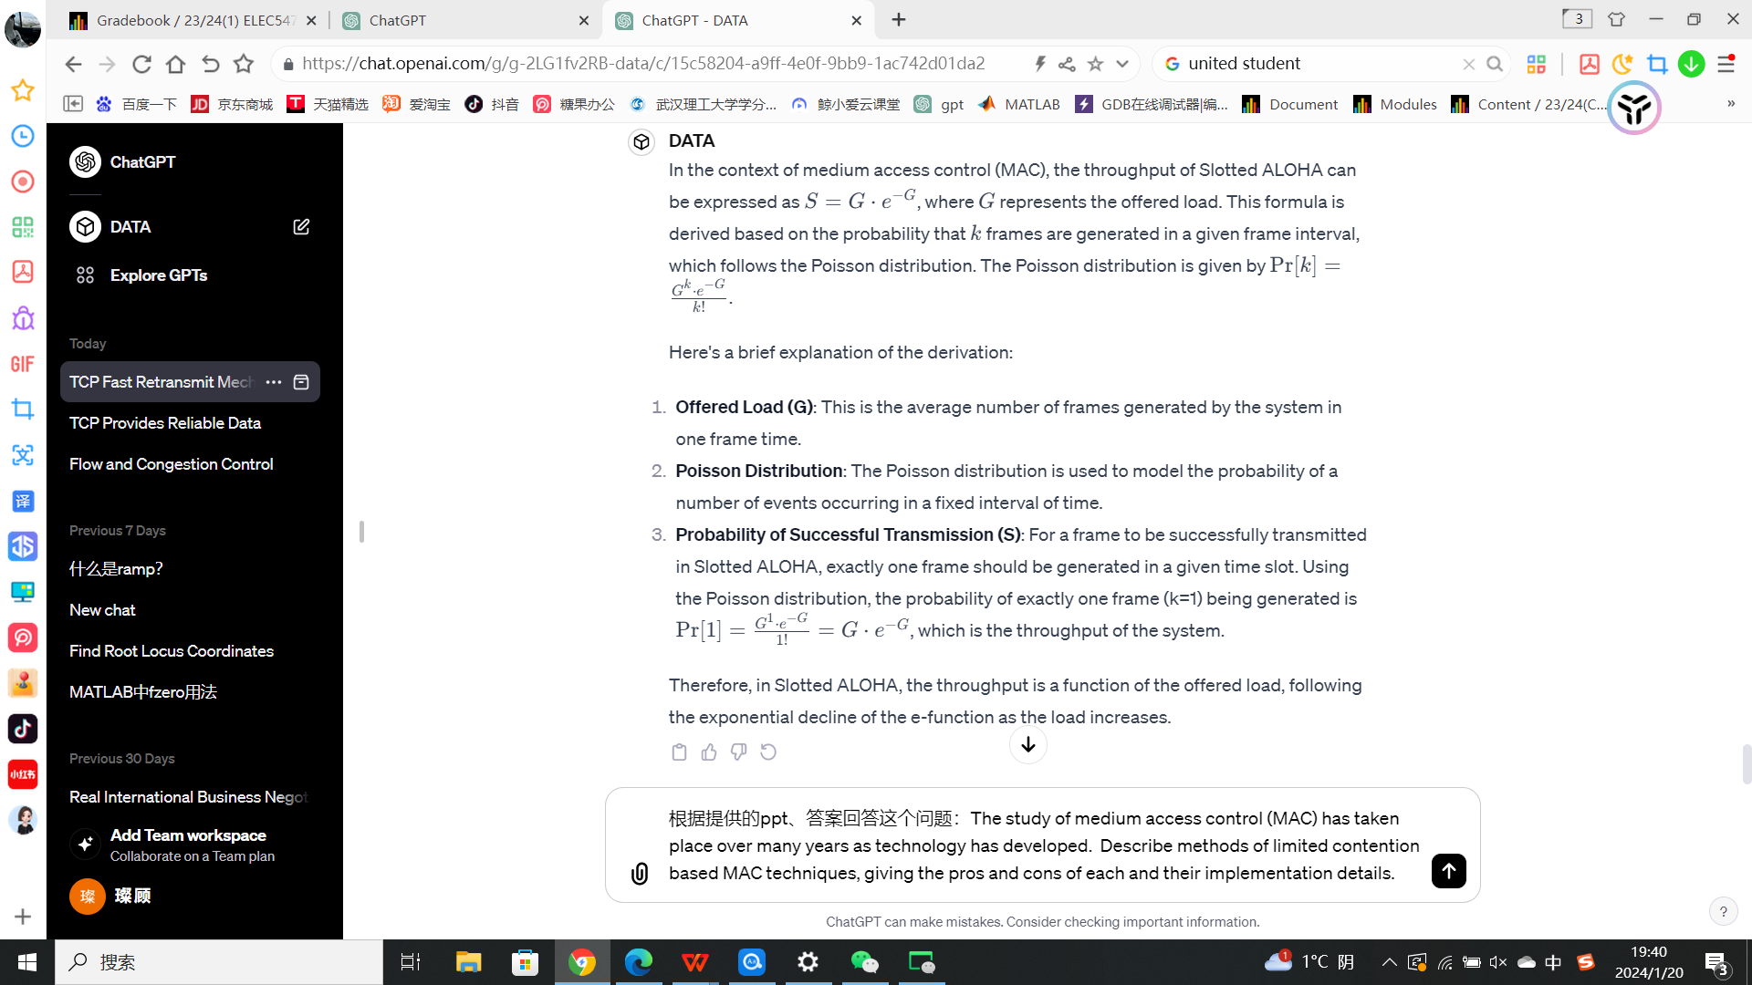

1. Describe methods of limited contention based MAC techniques, giving the pros and cons of each and their implementation details. *[6 marks]*

In the context of medium access control (MAC), limited contention-based MAC techniques include:

1.Binary Countdown:

Advantage: Allows for priority assignment among devices.

Disadvantage: Can be slow in determining which device gets access to the channel.

Implementation: Typically used in Control Area Network (CAN) systems.

2.Basic Bitmap:

Advantage: Simple and versatile, suitable for a range of applications.

Disadvantage: Adds delay and uses additional resources to determine which device will transmit.

Implementation: Implemented in technologies like the 802.15.4 MAC standard, often used in wireless sensor networks.

These methods are designed to reduce the contention for the medium, thereby optimizing the use of network resources and improving overall network efficiency​​.

**The End**